

**MANAV RACHNA UNIVERSITY**

**COURSE: BTECH CSE**

**SEMESTER – 3**

**----UI Project Report----**

**Khushi Arora**

**CSE 3C G2**

**2K20CSUN01058**

**LAB FILE**

**SUBMITTED TO: MS. DEEPANSHI GUPTA**

Phase 1: Website Purpose

**1. Website Purpose**

**paragraphs describing the overall purpose of the site. Is it an info site, a blog, a store, a site**

**for a business? Here are some questions to think about in preparing this first section:**

**Why should this website be made? What is the point?**

**Ans:** It is a portfolio with a blogging website. Here the person can showcase their skills through portfolio and at the same time write blogs about his latest projects and innovations all in the same place.

**Who is the target market/audience for this website?**

**Ans:** Everyone who are candidate for jobs and interested to showcase their skills.

**What problem does the product or service solve for the target audience?**

**Ans:** It has a portfolio where one can brief their skills and a blog section where they can elaborate on their projects.

Phase 2: Website Structure (UI)

1. **Website layout and breakdown**

**• Describe and outline the site layout/architecture and page map**

**What pages you will have**

**Ans:** Have 4 Sections:

1. Portfolio (Home)
2. Blog
3. Calculator
4. Case study

**o How your navigation menu will be organized**

**Ans:** Have 7 Sections:

1. Portfolio (Home)
2. Blog
3. Calculator
4. Case study
5. Contact us
6. Skills
7. About
8. **Website visuals of Home page / Landing page.**

**• In a graphic or visual, provide a rough mock-up of how these items on your website layout will be laid out in your main landing page.**

**o You can take a screenshot of another website or theme, and then lay over elements that you want included in your site using the snipping tool or even just typing directly over the screenshot in a Word file.**

**o You could take a blank page and a pen and ruler and draw it out. You could use an Adobe app or Canva to create a basic layout. How you do this is completely up to you.**

**Ans:**

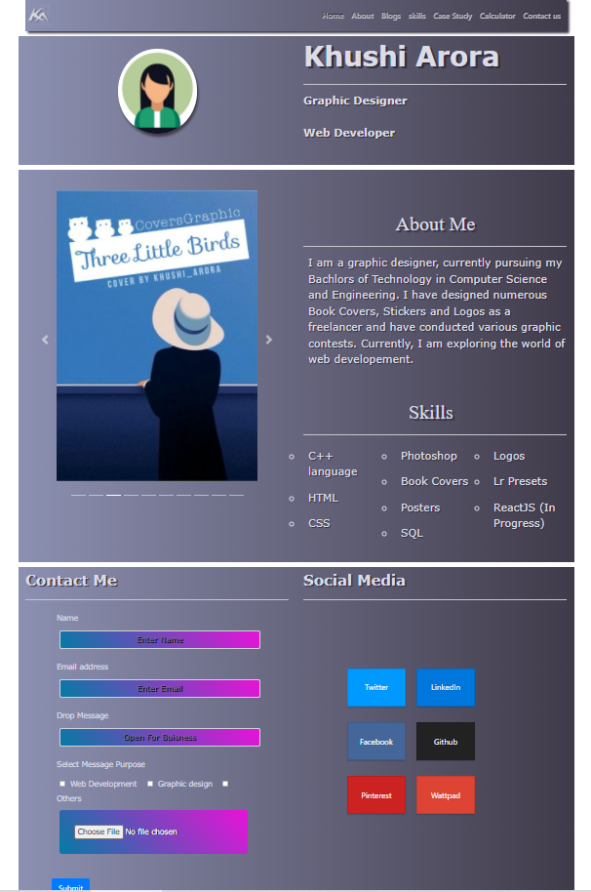

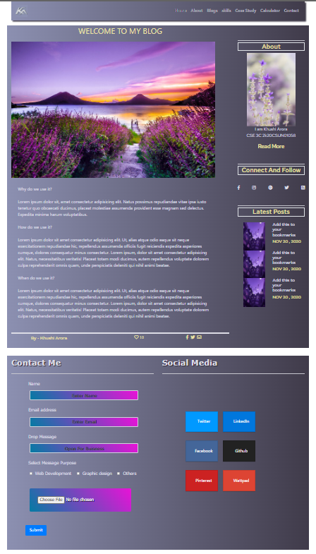

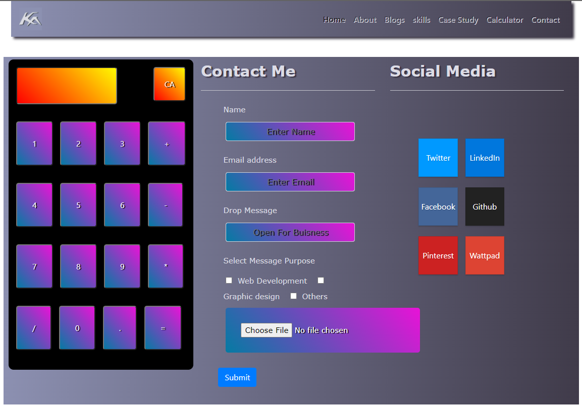

Phase 3: Website Development

**1. Website Development - How are you going to build this website?**

**• How will you choose your website theme?**

**Ans:** Aesthetically pleasing and professional

**• How long will each page be?**

**Ans:** not very long, 3-4 sections max.

**• Where will you source your graphics and images?**

**Ans:** Will be user’s own images of their projects.

**• Will you use any plugins to help you build the website? What ones? How will they help?**

**Ans:** Website is made from html, css, javascript, bootstrap and Nodejs and its modules.

**2. Website management - How are you going to update and manage the website?**

**Note: this is hypothetical. If you were to keep this website up to date after this course,**

**how would you do that?**

**• What is your plan for keeping your website updated with fresh, new content?**

**o What pages will need constant updating**

**Ans:** blog plage

**o How often you will be updating/creating content**

**Ans:** 3-4 times a year

**o How many hours a week or month**

Ans: 4-5hrs per month

**Phase 4: Website Strategies (SEO)**

**1. Website SEO - Think about 3 - 6 strategies**

**• Search Engine Optimization is critical in the success of your website, what strategies are**

**you going to use to optimize your website?**

**o Think about technical SEO too!**

**• What SEO plugins will you use? How will they help with your website’s SEO?**

**• Are there any other strategies you will use? Examples: keyword research, competitor**

**analysis**

**o Think about strategies you have learned in some of your other courses**

**Ans:** Learning how to optimize your website for SEO and conversions is crucial for your site’s

success.

It’ll ensure your website is working exactly as hard as it should. If you have good SEO, you can

attract more traffic and get more opportunities to convert potential customers.

And a website optimized for conversions typically has better metrics, such as time on page

and bounce rate, which means that Google might rank it higher.

The following tips and strategies will teach you how to optimize your website for both SEO and

conversions so you get the both of best worlds.

SEO helps your website become more discoverable. When potential customers search terms

related to your brand, they’ll have a better chance of discovering your website and becoming a

customer.

Imagine you have a fitness business. You offer dieting and workout tips on your website.

You also have an article about losing weight. With good SEO practices, a person searching a

keyword like “how to lose weight” might have a better chance of finding that article—and

therefore, your brand.

**Phase 5: Website Optimization (UX)**

**1. User Optimization - How are you going to optimize your user/customer experience?**

**• What types of optimizations will you include on your website, so your users have a great**

**experience?**

**o Think about Calls-To-Action, content length and layout, use of images, font choices, ease**

**of use, consistency.**

**Answer:**

1. Identify The Personality Of Your Brand.
2. Make The Website Load Faster.
3. Focus On Design Aspects.
4. Make Navigating On The Site Easy And Smooth.
5. Seduce Your Customers With Long-Form Content.
6. Ensure That The Content On The Site Is Top-Notch.

**2. Measuring your success**

**• Discuss what methods you will use to measure the success of your website User**

**Experience optimizations.**

**o What would you look for on the Google Analytics platform to determine how your users**

**are responding to your site content?**

**o Are there other tools you could use to measure user experience success?**

**Answer:**

1. Vamp up visitor privacy and security
2. Pay attention to site performance

### **Create a seamless experience on and offline**

### **Personalize your experience**

### **Optimize customer data from multiple channels**

### **Move forward with mobile**

### **Don’t forget to be social**

### **Create a Single Customer Profile from data**